**Experiment 1 Date : 15/04/2021**

**Aim: To design and develop static web pages(using only HTML and CSS) for a website of your choice.**

**Theory :**

**HTML:**

HTML stands for Hyper Text Markup Language.It is the standard markup language for creating Web pages.HTML describes the structure of a Web page.It consists of a series of elements

HTML elements tell the browser how to display the content.HTML elements label pieces of content such as "this is a heading", "this is a paragraph", "this is a link", etc.

**CSS:**

CSS is the language we use to style an HTML document.CSS describes how HTML elements should be displayed.This tutorial will teach you CSS from basic to advanced.

**Codes:**

<!DOCTYPE html>

<html lang="en">

<head>

<link rel="stylesheet" href="/css/home.css">

<meta charset="UTF-8">

<meta http-equiv="X-UA-Compatible" content="IE=edge">

<meta name="viewport" content="width=device-width, initial-scale=1.0">

<title>Homepage</title>

</head>

<body>

<div class="abt">

<ul>

<li class="tools"><a href="/html/AboutUs.html">about us</a></li>

<li class="tools"><a href="/html/Services.html">services</a></li>

<!-- <li class="tools"><a href="/html/Inventory.html">inventory </a></li> -->

<li class="tools"><a href="/html/Locate.html">locate us</a></li>

<li class="tools"><a href="/html/Contact.html">contact us</a></li>

</ul>

</div>

<div class="head">

<h1>

Welcome To VDV Solutions

</h1>

</div>

<div >

<!-- <h2>

Introduction

</h2> -->

<p class="intro">

At a time when everyone is scared to go out and buy hardware supplies we at VDV Solutions have

come up with the idea of delivering tools , steel , and so on directly to the site required and that too on the same day.

VDV Solutions also provides resin solutions , water proofing etc.

We are at a call's length one call and our associate will reach your site on the same day to give you

the best quotation.

</p>

</div>

<div class="images"> </div>

</body>

</html>

**Outputs:**

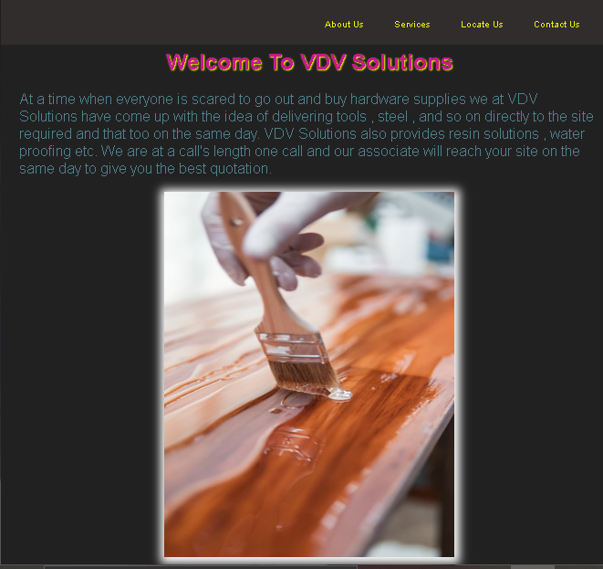

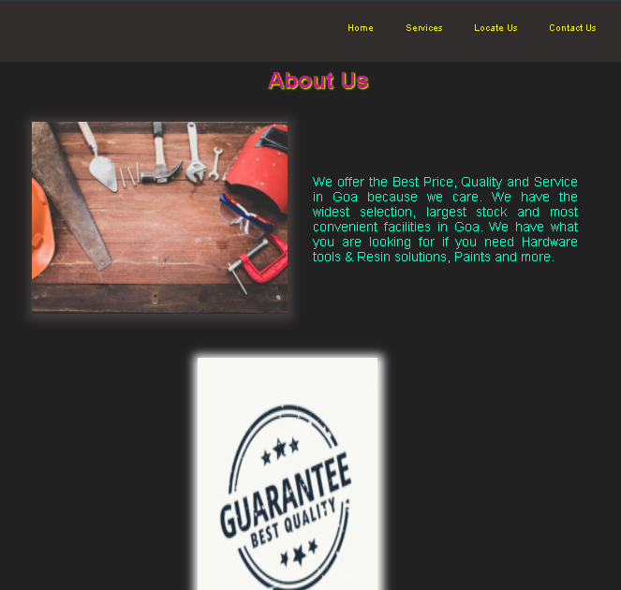

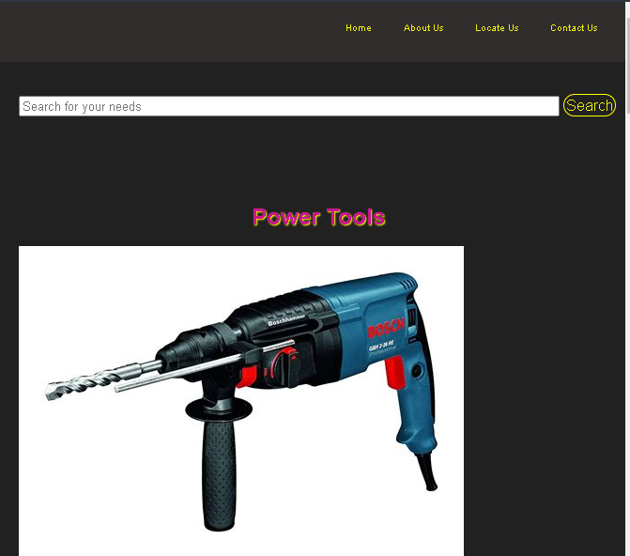

**Conclusion: Static web pages using HTML and CSS only were designed successfully.**